Payroll Management System

Student Name: Kavin Virgil Roy D L
Register Number: 921724115018
Department: Computer Science and Design
College Name: Sethu Institute of Technology
Course: Programming in C
Guide / Trainer Name: Balaji B
Submission Date: 26/02/2026

1. Abstract
The Payroll Management System is a C programming mini project designed to calculate employee salaries efficiently. The program accepts employee details such as Employee ID, Name, and Basic Salary. It automatically calculates HRA (20%), DA (10%), and PF (5%) deduction and displays the Net Salary. This project demonstrates the use of arrays, loops, and arithmetic operations in C programming.

2. Introduction
Managing employee salary manually is time-consuming and error-prone. This project automates salary calculation using C programming. It is useful in small organizations, academic projects, and beginner-level payroll systems.

3. Objectives
- Understand structured programming concepts.
- Use loops and arrays effectively.
- Perform salary calculations using arithmetic operations.
- Improve logical thinking and problem-solving skills.

4. System Requirements
- Hardware: Computer with minimum 4GB RAM.
- Software: C Compiler (GCC/ CodeBlocks / Turbo C) and IDE/Text Editor.
- Platform: Windows / Linux.

5. Methodology & Flowchart
The program follows a linear logic to process data:
- Read the number of employees.
- Input Employee ID, Name, and Basic Salary.
- Calculate $HRA = 20\%$, $DA = 10\%$, and $PF = 5\%$.
- Compute Net Salary and display results.
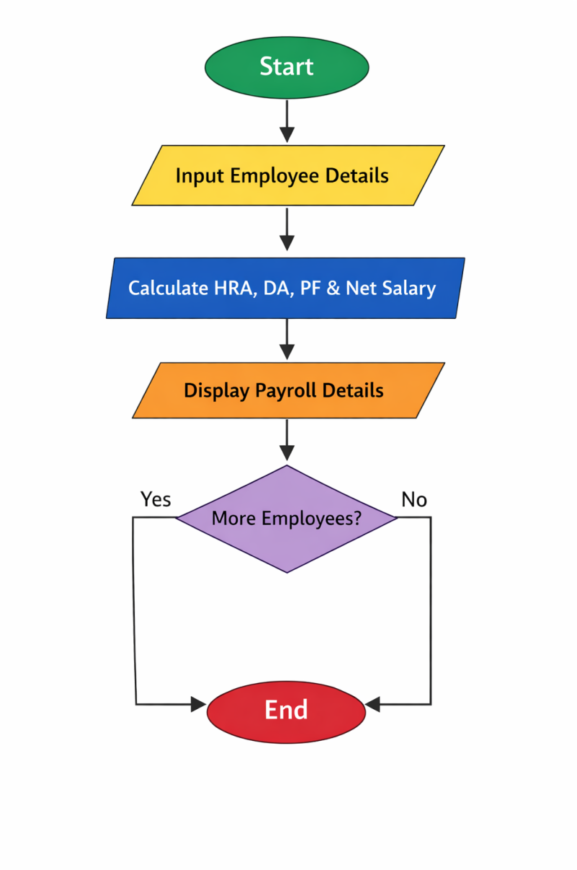
6. Program Code

#include <stdio.h>
int main() {
int n, i;
printf("Enter number of employees: ");
scanf("%d", &n);
int empId[n];
char name[n][50];
float basic[n], hra[n], da[n], pf[n], net[n];

for(i = 0; i < n; i++) {
printf("Enter Employee ID: ");
scanf("%d", &empId[i]);
printf("Enter Employee Name: ");
scanf("%s", name[i]);
printf("Enter Basic Salary: ");
scanf("%f", &basic[i]);

hra[i] = basic[i] * 0.20;
da[i] = basic[i] * 0.10;
pf[i] = basic[i] * 0.05;
net[i] = basic[i] + hra[i] + da[i] - pf[i];
}

for(i = 0; i < n; i++) {
printf("\nEmployee: %s | Net Salary: %.2f", name[i], net[i]);
}
return 0;
}

7. Sample Calculation
- Input Basic Salary: 20,000
- HRA (20%): 4,000
- DA (10%): 2,000
- PF (5%): 1,000
- Net Salary: 25,000

8. Conclusion & Future Enhancements
The system successfully calculates salaries accurately. Future versions could include file handling to store records, search/update features, and a menu-driven interface.

9. References
  - C Programming books
  - Online tutorials
  - Class notes

